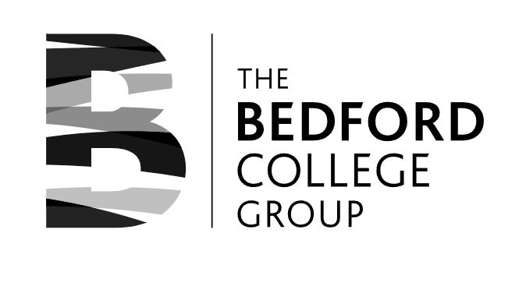
TBCG Subcontracting Payments 2024-25

UKPRN | Subcontractor | Funding Stream | Contract Start | Contract End | Funding to claim | Funding paid to subcontractor | Funding retained | %
10049354 | Arts 1 | 16-19 | 01/08/2024 | 31/07/2025 | £ 535,821.51 | £ 428,657.21 | £ 85,731.44 | 20%
10028441 | SSG | 16-19 | 01/08/2024 | 31/07/2025 | £ 220,770.00 | £ 176,616.00 | £ 35,323.20 | 20%
10031337 | Diverse FM | 16-19 | 01/08/2024 | 31/07/2025 | £ 401,570.92 | £ 321,256.74 | £ 64,251.35 | 20%
10034461 | Castleview | ASF | 01/08/2024 | 31/07/2025 | £ 161,041.21 | £ 128,832.97 | £ 25,766.59 | 20%
10028441 | SSG | ASF | 01/08/2024 | 31/07/2025 | £ 190,384.58 | £ 152,307.66 | £ 30,461.53 | 20%
10031337 | Diverse FM | ASF | 01/08/2024 | 31/07/2025 | £ 32,062.34 | £ 25,649.87 | £ 5,129.97 | 20%
Total: |  |  |  |  | £ 1,541,650.56 | £ 1,233,320.45 | £ 246,664.09 | 20%

