Before an exam consider...
- Your physical environment - Tidy and clean your airspace, organise yourself and your work, schedule your food and get into a good routine.
- Your support network - Who can you talk to if you feel your stress levels are rising? Who is not so helpful? You may want to consider putting boundaries in place to manage this. Is it helpful to study with peers on the same course? Or even friends from a different course?
- Preparation - Organise your modules, practice old papers, invest in coloured pens, index cards, Blu TacK etc.
- Planning - You may find a visual planner helpful (like the example below) in order to define when you will focus on revision for each module, incorporating all aspects of the foundations for good wellbeing (as seen below).
Download PDF’s of the Blank Weekly Planner

Foundations of good Wellbeing
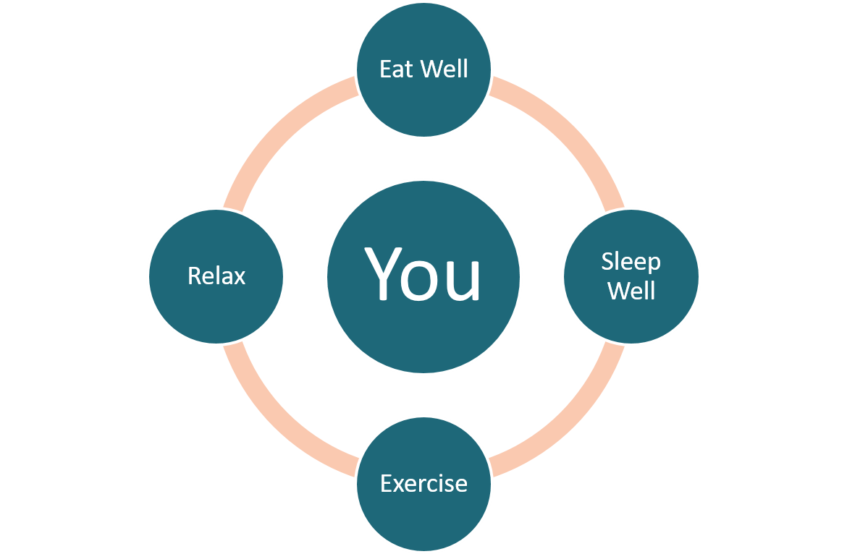
Sleep | Aids memory, information recall and good physical and mental health.
Relax | Take time out to relax and reduce your stress levels. Read, chat, dance, sing, play...
Exercise | Reduces stress, helps you think more clearly and helps you to sleep well.
Eating Well | Make time to stop and eat regular healthy meals. Your body and brain need fuel.

And Breathe...
- Take in a deep breath.
- Breathe right down into your stomach, not just into the top of your lungs but right down into your diaphragm.
- You will feel your stomach muscles engage which may feel a little uncomfortable if this is a new experience for you but stay with it.
- Visualise a jug filling up from the bottom and getting full but not overflowing.
- As you breathe out, imagine your stresses or worries leaving you with the breath.
- Keep going until you feel your stress begins to subside.

Tense and Relax...
- Sit comfortably in your chair.
- Ideally choose a time when you will not be interrupted.
- Tense one of your muscles just enough to notice what it feels like, but don’t over do it.
- For example, clench your fist, screw up your face muscles, scrunch your toes, hunch your shoulders.
- Hold the tension for about 3-5 seconds, then release.
- Once you have done this a few times, move onto another muscle.

During the exam....
- To manage your physical symptoms of anxiety try some of the techniques on this page (and breathe, tense and Relax and imagine yourself calm).
- If you notice that anxious thoughts are cycling (for example 'I'm going to fail, then I will be kicked out of university, I will disappoint everyone') you may want to try some quick distraction techniques such as counting backwards from 100 in 3's or naming an animal for each letter of the alphabet. You want this task to be hard enough to have to concentrate but simple enough to distract attention for a short time. Then continue with your exam.

After the exam
- Leave and avoid a post mortem
- Get some fresh air
- Eat
- Relax
- Do something you enjoy

Imagine yourself calm..
- Close your eyes and take a deep breath.
- Imagine a place that feels as calm and peaceful as you possibly can.
- You might imagine a sandy beach, a woodland, a place you visited as a child, a field, your bedroom– whatever is your ideal safe haven.
- Visualise this place in as much detail as you can.
- Notice how you feel in this place.
- If you don’t feel calm, try somewhere else.

